Muhammad Arif

Prof. Chuang

CISC 3140

March 5, 2021

Lab 4

Part 1

After installing PuTTY on Windows, I entered one of the given host IP address. I then received a warning message stating that you should only connect to servers that you know. After I clicked yes, the terminal started and asked for my account credentials. I did that and entered my Linux account credentials provided by Brooklyn College. I was then successfully connected.

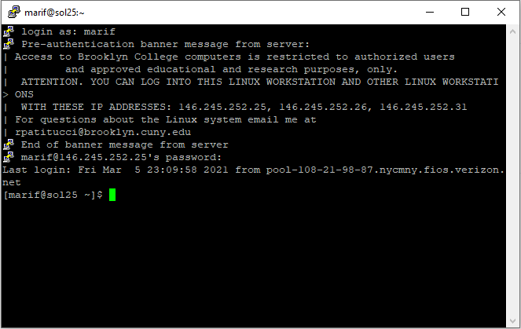

Part 2

Curl is used in command lines to transfer data.

Awk is a pattern scanning and processing language used as a data extraction and reporting tool.

Guile is the GNU project extension language designed to help programmers create flexible applications that can be extended by users with plug-ins, modules, or scripts.

Ffmpeg is a command for video converter.

Emacs is a text editor favored because it features efficient commands for common but complex actions.

Gzip is a file format and a software application used for file compression and decompression.

Head is used to copy and output the first part of files.

Convert is used to convert between image formats as well as resize an image, blur, crop, and other modifications.

Wget is used to download files from the web.

Java is used to launch a Java application.

Gimp is an image manipulation and paint program.

Vim is a powerful text editor used to edit configuration files.

MySQL command is a command interface to MySQL with input line editing capabilities.

Zip is used to package and compress files.

Tail as opposed to head, is used to copy and output the last part of the file.

Subversion is a popular open-source version control tool.

Git is a versatile version control system to track and handle file changes.

Inkscape is a scalable vector graphics editing program.

Nano is another text editor.

SQLite is another SQL engine that differs because it does not need configuration like the other databases.

Make is used to maintain, update, and regenerate groups of programs.

Part 3

Shortcuts:

* nano [fileName]: open an existing file, or create a new file
* nano +line_number and character number filename: open file with cursor on a line
* Ctrl+K: to cut
* Ctrl+U: to paste

How to Save nano .txt Files to Your Github Repo:

1. Copy the HTTPS code from the clipboard

2. Type into the command line: git clone your github link

3. cd into the repo you want to move it to

5. Type git add [name of file]

6. Then git commit -m with a message

7. Then git -config --global user.email with your email

8. Then git --config --global user.name with your username

git push

git status: to get the status of your file/repo